|  |
| --- |
| School of Electrical and Information Engineering  University of the Witwatersrand  [Wits EIE Logo](http://www.eie.wits.ac.za/) |
| ELEN7045 - SD Methodologies, Analysis and Design |
| The Account Presentation System |
| Submitted by:  Group 3  Sibusiso Zwane  Silas Mahlangu, 699358  Livious Ndebele, 701300  Sibusiso Zwane, 517473  Boithumelo Mhulong,  Bakwanyana Thobela, 855470 |
| Sibusiso Zwane |
| 8/26/2014 |

|  |
| --- |
|  |

Abstract

Contents

1. Introduction 4

2. Background 4

3. Methodology 4

4. Analysis 4

5. Design 4

6. Implementation 4

7. Discussion 4

8. Conclusion 4

References 5

Appendix 5

# Introduction

This report takes the reader through the process of how members of Group 3 used Software Development Methodologies, Analysis and Design techniques to solve a system development.

The reader will be given some a high level background of the problem. Then the methodology used to solve this problem is discussed. We show how Specification by example was used to understand the requirements during the analysis phase.

The reader is the shown how we used Domain Driven Design technique to ensure that the problem was solved in the problem’s domain context. The writing of the code, the implementation, was achieved by using Test Driven Development, Solid Principles and design patters, we show the reader how we used these techniques to solve the problem will be covered. A short conclusion ends the report.

# Background

The internet bubble introduced a lot of new solutions. Companies where predominantly Brick and mortar, with the internet era, a lot of these companies adopted the electronic commerce approach. We are currently in the information age. Customers have also changed the way they interact with businesses, the can now pay and view their statements online instead of visiting a physical store.

“*A customer who wishes to understand their financial situation at any point in time has to visit multiple websites and manually aggregate account information from different companies.* “ [1]

The purpose of this report is to show the reader the process followed to understand, design and implement the solution that provides a single point of access for all the customer’s statements from respective billing companies.

# Methodology

Given the short time frame given to develop this system, following a conventional software development model e.g. The WaterFall model, it was going to take longer to provide a solution. The brief specifies that the systems can me developed in phases, which is an instant advantage because it meant that the members can follow an Agile approach like Test Driven Development.

The systems was divided into respective subject areas and each member concentrated on a specific context of the problem. Regular Scrum Session where help once or twice a week on a need basis. Members also communicated challenges, insights and progress using Whatapp.

Most of the development was done by members at their own pace, at different geographic locations. They collaborated the efforts on a GitHub repository

# Analysis

4.1 Context Diagram

Context diagrams are easy to understand and helped us define the scope of the project. They help us visualize the model that depicts interactions of the system that need to be developed and the different entities it needs collaborates with.

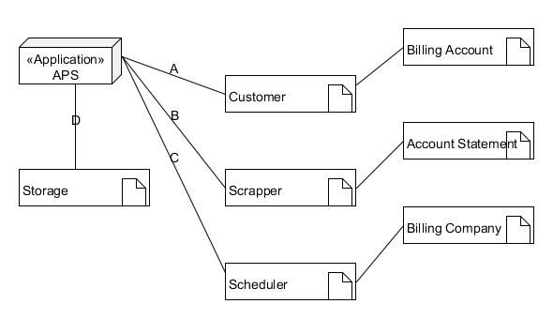

4.2 Sequence Diagrams

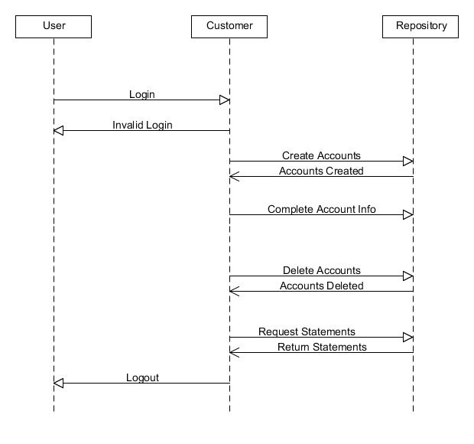

4.2 Specification by Example

Once the different aspects of the system where identified, we began the process of understanding the requirements and used a technique called Specification By Example.

# Design

DDD:

* Why?
* How?

TDD

* Why?
* How?

# Implementation

Design patterns

SOLID principles

# Discussion

# Conclusion

# References

# [1] Project Brief – ELEN7045

# Appendix